Medallion School of Distinction Program
School Social Media & Digital Marketing Toolkit
SECTION THREE: School Email Announcement

Updated January 9, 2020

SECTION THREE: Table of Contents

SCHOOL EMAIL ANNOUNCEMENT COPY 2
CUSTOM CONTENT 3
ASSETS TO INCLUDE 3

SCHOOL EMAIL ANNOUNCEMENT COPY

Use: Individual schools can upload the email graphic into its email marketing service (e.g. Mailchimp, Constant Contact, etc.) or directly into the body of an email to send through the school’s regular email service.

Audience: Parents and School Community

Email Subject Line: Fulfilling Our Commitment to Excellence

Graphic:
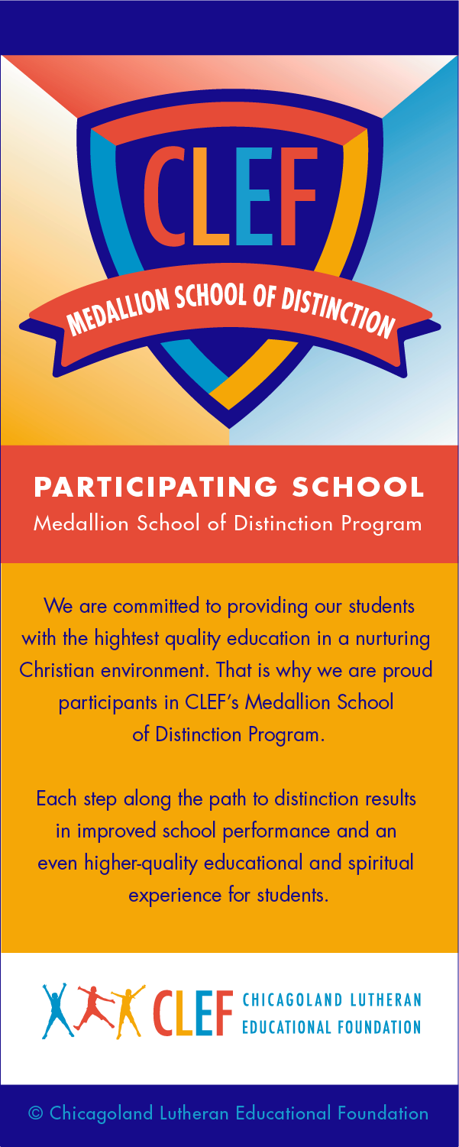

CUSTOM CONTENT
Each school can customize and include the following information below the email graphic:

For more information:
Contact [insert school/CLEF contact name and information]
Visit our website: www.xxxxxxxxxx.xxx {link to Medallion page on the school’s website – or link to CLEF’s Medallion webpage]
Read the article: Lutheran Education Journal: “Going for the Gold” {Link to article: https://lej.cuchicago.edu/columns/going-for-the-gold-clef-medallion-program-development/}
Follow us on social media: [School should include its own links to social media pages]

ASSETS TO INCLUDE

Graphics:
- Email graphic {above, also included as a loose .png in the Email Announcement folder]
- School logo
- School social media channel icons and links
Article Link:
- https://lej.cuchicago.edu/columns/going-for-the-gold-clef-medallion-program-development/

Website link:
- To School’s Medallion page (if relevant
- To CLEF’s Medallion page: {link forthcoming}

