Medallion School of Distinction Program
School Social Media & Digital Marketing Toolkit
SECTION FIVE: Social Media Post Copy & Graphics

Updated January 10, 2020

SECTION FIVE: Table of Contents

BASIC ACTIVITIES YOUR SCHOOL CAN DO ON SOCIAL MEDIA 2
HASHTAGS 2
“EVERGREEN” CONTENT (POST ANYTIME) 3
SEASONAL COPY SUGGESTIONS 6
CUSTOM CONTENT SUGGESTIONS 8
SOCIAL MEDIAL SEASONAL HASHTAG CALENDAR 8

BASIC ACTIVITIES YOUR SCHOOL CAN DO ON SOCIAL MEDIA
- Like, Comment & Share: When CLEF tags your school you will be notified and can then like and comment on it to get visibility with CLEF’s audience. You can also share the post with your own network and add a comment of your own.
- Post Your Own Content: Select from the content provided below (or create your own) to educate your social media audiences about your participation in the Medallion School Program.
  - “Evergreen” Content [Post anytime]: PAGE 3
  - Seasonal Content: PAGE 6
  - Custom Content Suggestions: PAGE 8

HASHTAGS
 | Content | Usage Best Practices
Program Hashtags | #CLEFMedallion  #SchoolofDistinction  #PathwayToExcellence | Use no more than 2 for Facebook  Use up to 9 for Instagram  Use when seasonal relevant to link to broader conversations
Top Facebook Hashtags | #love  #photooftheday  #ThrowBackThursday, #tbt
Top Instagram Hashtags | #love  #instagood  #photooftheday  #happy  #cute  #tbt
Examples of Seasonal/Topical Hashtags | #martinlutherking  #NLSW20  #BlackHistoryMonth  #GroundhogDay  #SuperBowlLIV  #WomensHistoryMonth  See Social Medial Seasonal Hashtag Calendar for additional Hashtags
Social Media Handles | @CLEFChicago  Your school’s @handle  Alumni or parent group @handle  Church @handle  Community partner groups’ @handle | Include in copy to “tag” groups or organizations referenced in text.  Using a @handle will inform that group that they have been tagged by you in a post

“EVERGREEN” CONTENT (POST ANYTIME)
- Copy: We are on the Pathway to Increasing Excellence! [School name] is officially taking its first steps towards earning @CLEFChicago’s Medallion School of Distinction award. Follow along on our journey towards greater academic excellence! #CLEFMedallion #SchoolofDistinction

Notes: Customize by tagging specific groups, congregations, partners, etc.
Graphic to Include:
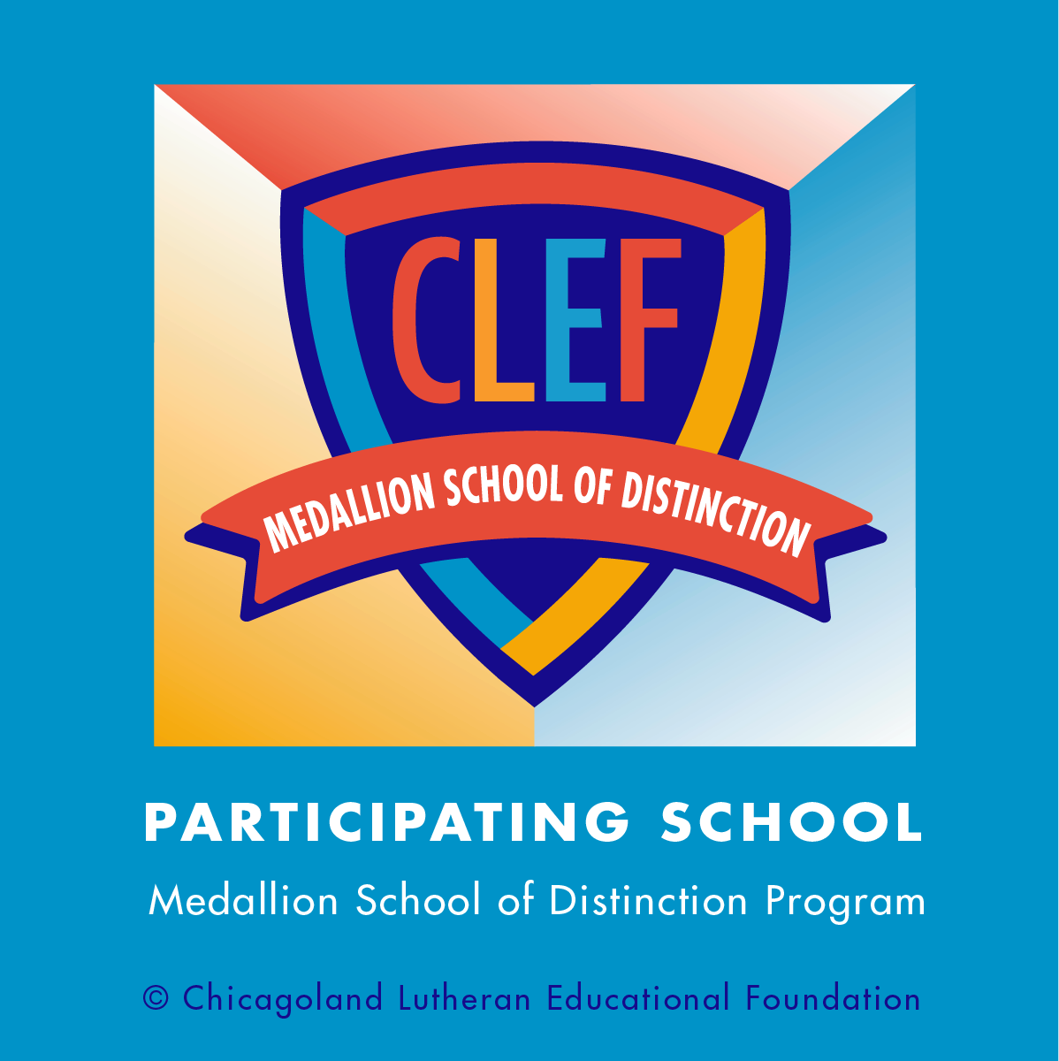

- Copy: Each badge earned in the #CLEFMedallion School of Distinction Program supports enhancements in academics, innovative instruction, and sustainability that benefit our students and families. #SchoolofDistinction

Notes:
- Add @handles for parent, alumni and church groups
- Use the graphic provided or a photo of your school community in action

Graphic: upload with photo of students from your school engaged in classroom exercises

- Copy: The #CLEFMedallion School of Distinction program is supporting [school name] to enhance #AcademicExcellence in a faith-based environment. Read more in this article by @CLEFChicago in the Lutheran Education Journal! [link to article: https://lej.cuchicago.edu/columns/going-for-the-gold-clef-medallion-program-development/

Graphic: Stock image or graphic based on the article content

Notes:
- Including the article link will automatically pull an image into your Facebook post. You should override this by uploading your own image
- Use the graphic provided or a photo of your school community in action

- Copy: Through the #CLEFMedallion Program our school has access to instructional and leadership coaches, professional development, peer support and subject matter experts. We are continuing to advance along the #PathwaytoExcellence!

Graphic Direction: photo of teachers engaged in ITI or other professional development

Notes: Use the photo provided or insert a photo of your teachers or school leader engaging in the classroom with students

- Copy: We are committed to providing our students with #AcademicExcellence in a nurturing Christian environment. That is why we are proud participants in the #CLEFMedallion School of Distinction Program. Thanks @CLEFChicago for your support of our mission! Find out more [link to school or CLEF webpage]

Graphic Direction: Image that illustrates academic excellence in a nurturing environment. OR image that illustrates following through on a commitment to excellence in education

- Copy: “Continuous improvement is better than delayed perfection.” We feel the same way, Mr. Twain! There is always room for improvement, especially when it comes to our students’ academic and spiritual experience. That is why we are working towards recognition as a #CLEFMedallion school! [Optional: Find out more about our journey (link to video or webpage with more information)]

Graphic Direction: [meme/image illustrating the Mark Twain quote in the post]

- Copy: The #CLEFMedallion School of Distinction Program provides a roadmap for continuous improvement by defining rigorous criteria and standards of excellence based on educational best practices. Learn more about how the program was designed: [link to article: https://lej.cuchicago.edu/columns/pathways-to-excellence/

Graphic Direction: Image illustrating a “roadmap” for continuous improvement [forthcoming]

- Copy: “Without continual growth and progress, such words as improvement, achievement, and success have no meaning” - Benjamin Franklin. We take this message to heart, that’s why we are on the #PathwayToExcellence to become a #CLEFMedallion school. Find out more: [insert link to school or CLEF page on Medallion]

Graphic Direction: Image illustrating Benjamin Franklin quote

- Copy: Our teachers are learning cutting edge approaches to teaching math and literacy through the instructional coaches and professional development offered as part of the #CLEFMedallion School of Distinction program. Watch this video to learn more about the impact in the classroom [link to video testimonial]

Graphic Direction: Video testimonial from a teacher about instructional coaching and professional development. NOTE: this would need to be done by each school but CLEF could provide ideas for how to do it.

- Copy: Each badge earned towards becoming a #CLEFMedallion School of Distinction is a recognition that we have met criteria of excellence developed by @CLEFChicago in partnership with @ConcordiaUniversityChicago and other experts in #AcademicExcellence, #ChristianEducation and mission-driven leadership.

Graphic:

- Copy: Through the #CLEFMedallion School of Distinction Program we will earn financial awards that can be used to support student scholarships, educational programming, and opportunities to enhance student educational experience.

Graphic Direction: Image illustrating $ earned and what the money could support

SEASONAL COPY SUGGESTIONS
JANUARY 2020

Monday, Jan. 20: Martin Luther King Jr. Day (Observed)

Copy: Martin Luther King, Jr. was an advocate for education as an important step on the way to equality. At [school name] we strive to educate the hearts, minds, and spirits of the students and families we serve. #MLKDay #CLEFMedallion

Graphic:

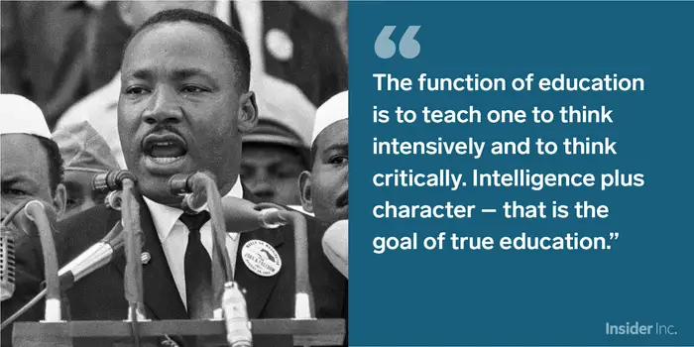
Select from Pixabay 50+ free MLK Jr. Photos
Famous quotes: Top 20 Inspiring Quotes
Or insert photos of your students/school honor MLK Day

Jan. 26–Feb. 1, 2020: National Lutheran Schools Week

Copy: This year we are celebrating National Lutheran Schools Week by working towards our #CLEFMedallion School of Distinction award to recognize our high-quality education in a Lutheran environment. Stay tuned to track our progress and celebrate our success! #NLSW20

Graphic:
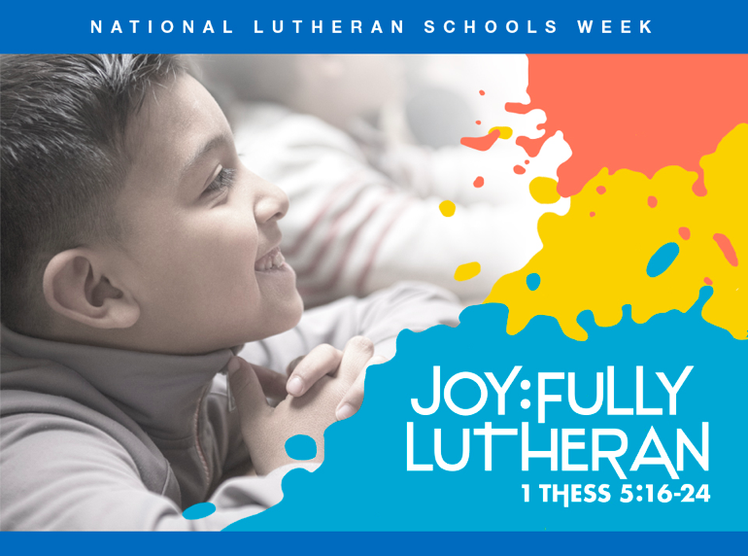

Or include photos of your students/school’s National Lutheran Schools Week activities

For a complete manual of DAILY content and resources related to National Lutheran Schools Week from the Missouri Synod click here.

FEBRUARY 2020

All Month: Black History Month #BlackHistoryMonth

February 2, 2020: Super Bowl #SuperBowlLIV

Super Bowl Special Copy: We are going for a touchdown in academic excellence! For each badge we earn on the way to becoming a #CLEFMedallion School of Distinction our school earns money it can use to support our students and teachers! Plus, we get to do the touchdown dance :) #SuperBowlLIV or #SBLIV

Graphic:
Touchdown gif 1
Touchdown gif 2

CUSTOM CONTENT SUGGESTIONS

- Testimonial from your school leader about the school’s participation in the Medallion Program
- Update on the school’s progress through the program
- Photo/video illustrating an area of the Medallion program
- Content tied to school functions or activities
- Interactive questions or polls to gather audience feedback
- Posts tied to seasonal or school calendar activities

SOCIAL MEDIAL SEASONAL HASHTAG CALENDAR

JANUARY
Monday, January 20 | Martin Luther King, Jr. Day (observed) | #MLKDay
Tuesday, January 21 | National Hugging Day | #NationalHuggingDay
Thursday, January 23 | National Pie Day | #PieDay
Friday, January 24 | National Compliment Day | #NationalComplimentDay
Saturday, January 25 | Chinese New Year | #YearOfTheRat
Saturday, January 25 | Opposite Day | #OppositeDay
Monday January 26 – February 1 | National Lutheran Schools Week | #NLSW20
Friday, January 31 | Backwards Day | #BackwardsDay
FEBRUARY
All Month | Black History Month | #BlackHistoryMonth
Sunday, February 2 | Groundhog Day | #GroundhogDay
Sunday, February 2 | Super Bowl LIV | #SBLIV
Friday, February 7 | National Bubble Gum Day | #BubbleGumDay
Friday, February 7 | National Send a Card to a Friend Day | #SendACardToAFriendDay
Sunday, February 9 | Academy Awards | #AcademyAwards
Sunday, February 9 | National Pizza Day | #NationalPizzaDay
Tuesday, February 11 | Safer Internet Day | #SID2019
Friday, February 14 | Valentine's Day | #ValentinesDay
Monday, February 17 | Random Acts of Kindness Day | #RandomActsOfKindnessDay
Monday, February 17 | Presidents Day | #PresidentsDay
Thursday, February 20 | World Day of Social Justice | #SocialJusticeDay
Saturday, February 22 | National Wildlife Day | #NationalWildlifeDay
Tuesday, February 25 | Mardi Gras | #MardiGras
Wednesday, February 26 | Ash Wednesday | #AshWednesday
February 26 - April 10 | Lent | #Lent
Saturday, February 29 | Leap Year Day | #LeapYearDay2020
MARCH
All Month | Women’s History Month | #WomensHistoryMonth
February 26 - April 10 | Lent | #Lent
Monday, March 2 | National Read Across America Day | #ReadAcrossAmerica
Tuesday, March 3 | World Wildlife Day | #WorldWildlifeDay
Wednesday, March 4 | National Grammar Day | #NationalGrammarDay
Friday, March 6 | National Employee Appreciation Day | #EmployeeAppreciationDay
Sunday, March 8 | International Women's Day | #BeBoldForChange
Sunday, March 8 | National Proofreading Day | #NationalProofreadingDay
Sunday, March 8 | Daylight Savings | #DaylightSavings
Monday, March 9 | National Napping Day | #NationalNappingDay
Tuesday, March 10 | National Pancake Day | #NationalPancakeDay
Tuesday, March 10 | National Pack Your Lunch Day | #NationalPackYourLunchDay
Saturday, March 14 | Pi Day | #PiDay
Monday, March 16 | National Freedom of Information Day | #FreedomOfInformationDay
Tuesday, March 17 | St. Patrick's Day | #StPatricksDay
Wednesday, March 18 | Awkward Moments Day | #NationalAwkwardMomentsDay
Thursday, March 19 | National Let's Laugh Day | #NationalLetsLaughDay
Thursday, March 19 | First Day of Spring | #FirstDayofSpring
Friday, March 20 | International Day of Happiness | #InternationalDayofHappiness
Friday, March 20 | World Storytelling Day | #WorldStorytellingDay
Saturday, March 21 | Elimination of Racial Discrimination Day | #RacialDiscriminationDay
Saturday, March 21 | World Poetry Day | #WorldPoetryDay
Sunday, March 22 | World Water Day | #WorldWaterDay
Monday, March 23 | National Puppy Day | #NationalPuppyDay
Saturday, March 28 | Earth Hour Day | #EarthHour

Source: https://www.softwarepundit.com/seo/social-media-holiday-calendar-2020#nogo

