Medallion School of Distinction Program
School Social Media & Digital Marketing Toolkit
SECTION TWO: School Website Copy & Digital Banners

Updated January 9, 2020

School Website Copy & Digital Banner/BadgeUse: A school can insert the following copy and/or web graphic into an existing page of its website, or create a new page, to highlight the school’s commitment to advancing excellence in education, operations and sustainability. The ability to modify web pages will vary based on the schools website platform.
Posting Timeline: January 2020

Suggested Copy:
Section Headline: On the Pathway to Enhancing Academic Excellence and School Performance
We want your child to have the best possible learning experience that prepares him or her for the rigors of highschool and the challenges of becoming a young adult. Our commitment to continuously improving academic excellence to support student growth is demonstrated by our participation in Chicagoland Lutheran Educational Foundation’s Medallion School of Distinction program [link to CLEF’s website]. Through this program, we will pursue excellence in eight categories critical to school performance and sustainability.
Download the FAQs [link to downloadable PDF or FAQ page on CLEF’s website] or contact: [insert school contact name and information] to learn more about how [our /[school’s name] participation in this program will benefit you and your student.

Links/Assets to Use:

Link to FAQ: to be inserted
Link to CLEF Medallion Web Page: to be inserted

Graphics: [Also included in the folder as loose .png files]
Leaderboard:

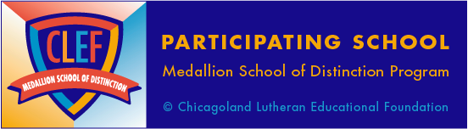

Vertical Banner Ad:
