Medallion School of Distinction Program
School Social Media & Digital Marketing Toolkit
SECTION FOUR: Newsletter General Announcement

Updated January 9, 2020

SECTION FOUR: Table of Contents

NEWSLETTER - GENERAL MEDALLION ANNOUNCEMENT COPY 1
GRAPHICS: 2
ASSETS TO INCLUDE: 3

NEWSLETTER - GENERAL MEDALLION ANNOUNCEMENT COPY

Use: Individual schools can insert this into a school community newsletter (print or digital)
Audience: Parents and Members of the School Community

Article Title:
Our Commitment to Continuous Improvement
Participation in CLEF’s Medallion School of Distinction Program Means Increased Attention on Academic Excellence and the Student Experience

We are pleased to announce that in October 2019, [school name] signed on to participate in the Chicagoland Lutheran Educational Foundation’s (CLEF) Medallion School of Distinction Program [link to school or CLEF Medallion webpage]. CLEF is a longtime supporter of our school and Lutheran Education in Chicago.

As participants in the CLEF Medallion Program, we are working towards earning badges in eight areas critical to school excellence, including: curriculum and student learning; learning innovation; governance; financial sustainability; Christian principles and spiritual formation, community engagement; facilities and infrastructure; and health and wellness. [School may list by name or insert badge graphics]

Participation in the program grants our school leaders and teachers access to instructional and leadership coaches and ongoing professional development training. These support services will improve what our school offers to your child. Additionally, once a badge is earned our school will receive a financial award acknowledging our success. This award will support more programs and services that enhance your child’s experience at [Name of School].

CLEF’s Medallion School of Distinction and its Pathways to Excellence programs were recently featured in the Lutheran Education Journal . Read the articles to learn more:
- “Going for the Gold: CLEF Medallion Program Development”
- “Pathways to Excellence”
- “A CLEF Board Member’s Perspective on Pathways to Excellence”

For more information, contact [insert school contact name and contact information].
We will keep you posted as we advance along the pathway of excellence to earn our Medallion School of Distinction award!

Follow us on [insert social media channels your school uses] to stay in the know!

GRAPHICS:
[Also included in the folder as loose .png files]
Leaderboard:

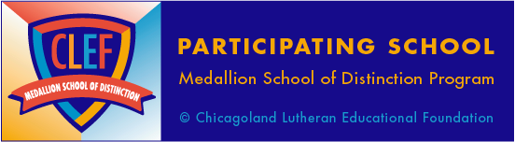

Vertical Banner Ad: Square ad/Post:
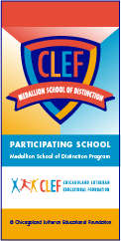
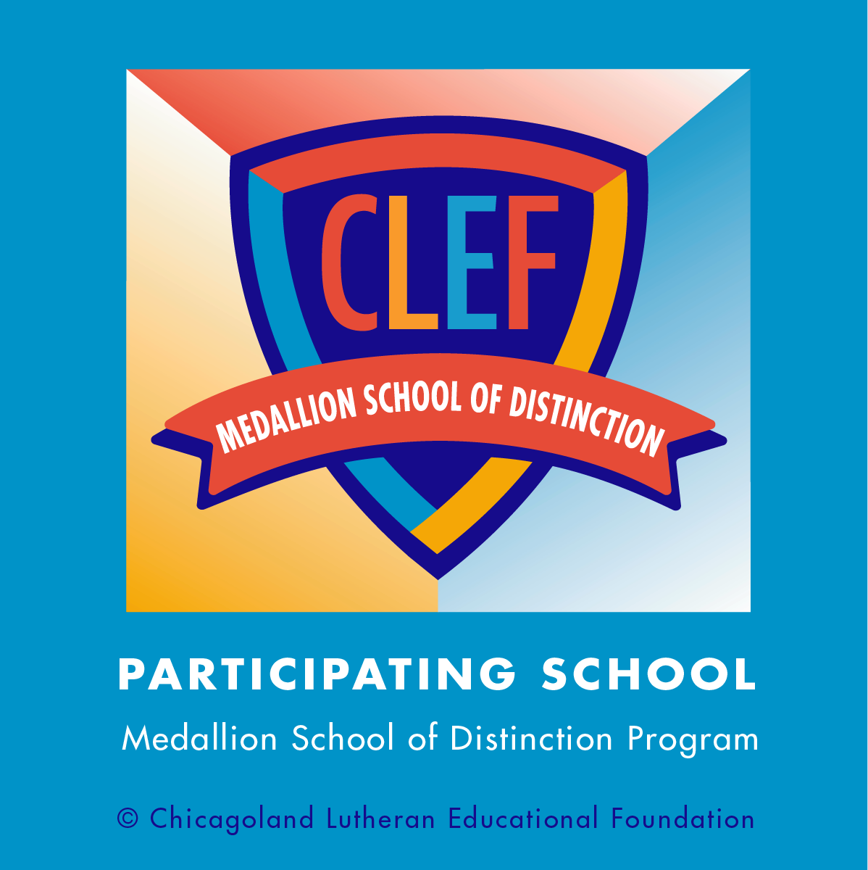

ASSETS TO INCLUDE:
Article Links:
- https://lej.cuchicago.edu/columns/going-for-the-gold-clef-medallion-program-development/
- https://lej.cuchicago.edu/columns/pathways-to-excellence/
- https://lej.cuchicago.edu/uncategorized/a-clef-board-members-perspective-on-pathways-to-excellence/
- Link to CLEF Medallion Web Page: to be inserted

Graphics:
- “Participating School” graphic [see below]
- School logo
- School social media channel icons and links

